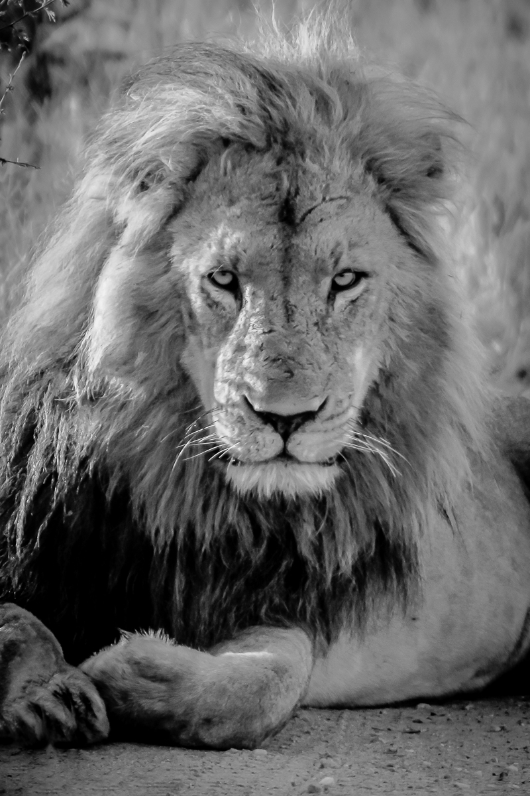

May, 2025 | CentrE for animal-based tourism

Centre for Animal-based Tourism

C.A.T.

Preamble

The general problem

The specific problem

What’s the solution?

CAT: a research center like no other

Mission and vision statements

Measuring success: goals and objectives

Proposed research projects

Realizing the vision

Budget

Bibliography

Preamble
________________________________________________________________________________________________

Historical and contemporary uses of animals in tourism range widely: animals are viewed in the wild (e.g., ecotourism) and in captive settings (e.g., circuses and zoos); used for their strength (e.g., ridden or harnessed); forced to fight or compete for public amusement (e.g., rodeos and bullfighting); and fished and hunted. At the heart of the many complex problems plaguing animals in tourism is a blend of socio-cultural, economic, environmental, legal, and political issues that define the ethical landscape of animal use. Deep-rooted cultural practices induce suffering and deprivation in animals in a climate of poor welfare standards, disrespect, and the denial that animals possess species-specific cognitive and emotional capabilities beyond simply instinct.

Tourism industry practitioners, policymakers, and tourists cannot emerge from these entrenched pathways because of a lack of knowledge, willful neglect, and a focus on profit maximization. Ignorance has thus become a default state in the unregulated animal-based tourism industry, with tourists unable to provide negative feedback to operators because of their own lack of animal welfare and conservation literacy. However, times are changing, and the tourism industry, collectively, must keep pace with new emerging realities around sustainability, responsibility, animal welfare, biodiversity conservation, and a wave of new sensitivities on the value of nature.

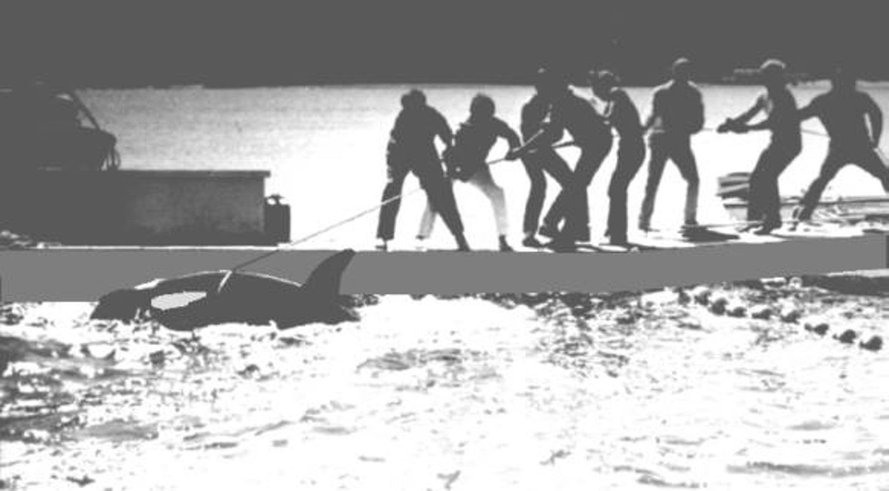

The greatness of a nation and its moral progress can be judged
by the way its animals are treated.
-Mahatma Gandhi

The general problem
____________________________________________________________________

Animals are under threat from a range of different uses. Prime examples include animal experimentation, factory farming, the cosmetics industry, and poaching, along with more general changes brought about through climate change and biodiversity loss (Lewis & Maslin, 2015). The following few examples show how dire the situation is regarding biodiversity loss alone:

- Orangutans: 80% of their habitat lost in the last 20 years via deforestation.
Scientists predicting extinction in wild <50 years (Orangutan Conservancy, 2019).

- Africa’s lion population reduced from 100,000 to 32,000 over a period of 50 years.
Reason: habitat loss due to human encroachment (Eilperin, 2012).

- African elephants: 8% (27,000 elephants) lost/year of an already dwindling population, Reason: poaching and habitat loss (Steyn, 2016).

In fact, a weighing of the totality of terrestrial vertebrates describes how lopsided the equation is: Human beings account for 30% of this global mass, farm animals 67%, and wild animals just 3% of the total (Hamilton, 2017). We are now faced with the prospect of having many of the Earth’s most charismatic species “living” in built settings such as zoos and sanctuaries within a period of 50 years.

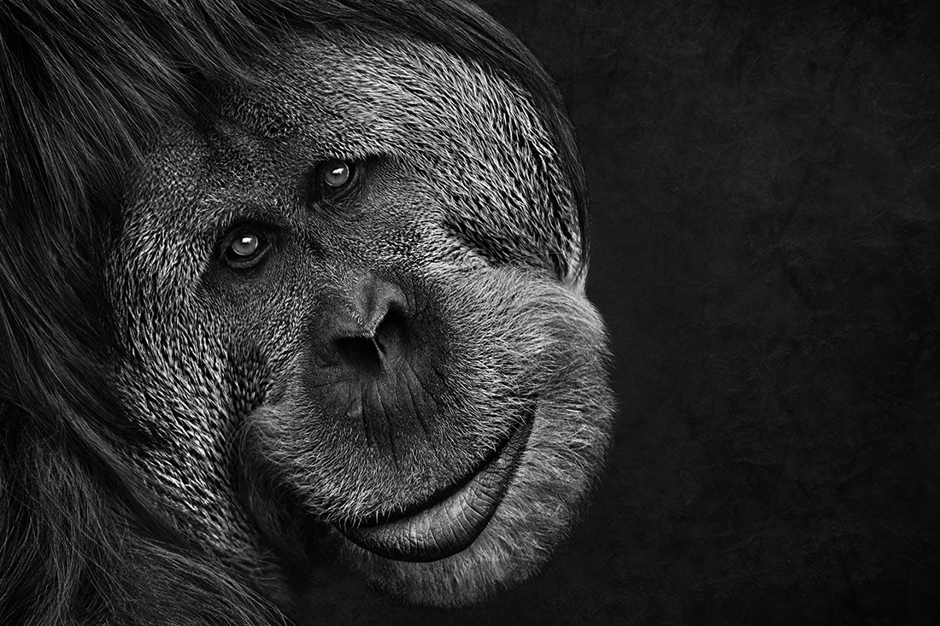

The specific problem
____________________________________________________________________

Tourism is the world’s biggest industry, and it uses an estimated 100 million animals as workers and entertainers (Phillips, 2009) with few boundaries. Dogs in Bali are brutally killed with their meat sold to unsuspecting tourists; baby dolphins are taken out of the water for selfies for so long that they end up dying; bullfighting in Spain and Mexico; calf roping at rodeos; circus abuse; greyhounds living in cages for 22 hours a day; feeding live chickens to lions in Chinese zoos; donkeys forced to give rides to tourists in 120°F heat; and tigers drugged and abused for tourist photos. These are just the tip of the iceberg. Others include:

The elephant phajaan:
Literally breaking the spirit and will of an elephant. Young elephants are kept in wooden enclosures for 3-6 weeks, and tortured for the sole aim of inducing fear so handlers can better train and control them for tourism purposes (Graham, 2010).
https://www.unilad.co.uk/animals/tourists-urged-not-to-ride-elephants-in-thailand-as-horrific-photos-emerge/

Canned hunting:
Lions and other big cats bred to be set free in small enclosures for hunters to kill, usually within five minutes.
See Blood Lions: https://www.youtube.com/watch?v=-T86GCjCpus&feature=youtu.be

Killer whales and dolphins at aquaria:
Forced to perform endless, repetitive tricks for crowds, many dolphins practice self-induced asphyxia—they choose not to take another breath. The industry is so heinous that former trainers, like Ric O’Barry (trainer from the TV show Flipper), have dedicated their lives to ending this practice
See Lolita: Slave to Entertainment: https://www.youtube.com/watch?v=rWDL_bhDFwA

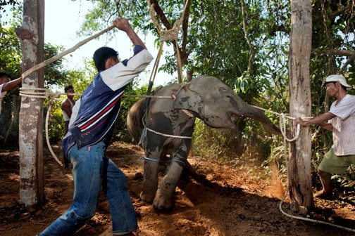

What’s the solution?
____________________________________________________________________

Given the cultural and commercial challenges that persist in the use of animals on so many levels, how do we move ourselves out of the Dark Ages of archaic tourism practices and into a brave new world? In the words of two of the most influential conservationists in the present day, Jane Goodall (Chimpanzees in Africa), and Lek Chailert (elephants in Thailand): education. This is the primary message of the recent film, Love and Bananas https://www.youtube.com/watch?v=E0kUJY62I4Y

We can only move the agenda forward if we embark upon a comprehensive journey that involves cutting-edge research, public education, raising awareness in all sectors of the tourism industry, and helping industry develop and refine animal best practices. But it will also take courage, will, and commitment.

We also believe that the snowball effect of new knowledge and information on proper animal practices in tourism will impose social costs. This means that for tourists and operators who continue poor animal practices, society will have a way of imposing its will on these people through social and economic penalties. So, in the new sustainable and responsible tourism world of the near future, a firm’s competitive advantage will be realized, in part, by its ethical treatment of animals.
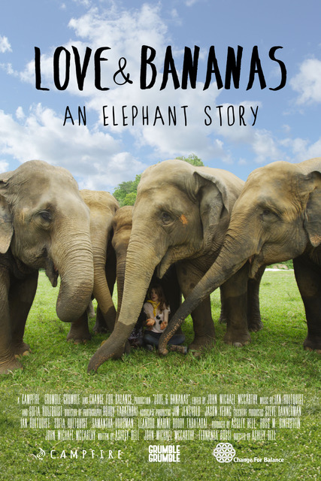

CAT: A research center like no other
_______________________________________________________________________________________

CAT will be unlike anything that currently exists. There are several conservation research centers in existence, a few centers of ethics, and even centers for animal ethics. However, CAT is unique because it unites expertise in four essential areas: animal welfare and ethics, ecotourism, education and literacy, and conservation—all targeted on the use of animals in tourism. This makes it the only one of its kind in the world.

The intent is to disrupt and transform current knowledge and practice in the use of animals in tourism by the combined forces of the model, below. Research on these four principal components will drive essential changes in the practice of using animals for tourism. All of this demands the implementation of good governance motives (the yellow circle of the model) for the proper operationalization of animal-human principles and practices for the benefit of both.

Mission and vision statements
_________________________________________________________________________________

By ignoring the fact that animals suffer as workers in tourism we imply that they have no interests: interests in not suffering, interests in being with their own kind, and interests in expressing normal behavior. Tourism fails as a practice because it is not protective of those beings that, by virtue of their involvement as workers (unwilling as they may be), are often an essential part of the industry. If responsible tourism is really about amending power imbalances and disparities, the time has come for an expansion of the circle of morality to include animals as well.

An expanding circle of morality that includes animals gives us the opportunity to express values that are not just tied to pleasure and profit, but rather those of a different nature and scale. In transforming the global landscape in how we value, perceive, and prioritize animal use in tourism (a reduction in use, or no use at all in certain contexts), the following mission and vision statements act as the foundation of CAT.

CAT’s Mission:
To move knowledge into practice for the just treatment of animals in tourism.

CAT’s Vision:
A global tourism industry that values and respects the
wellbeing of animals.

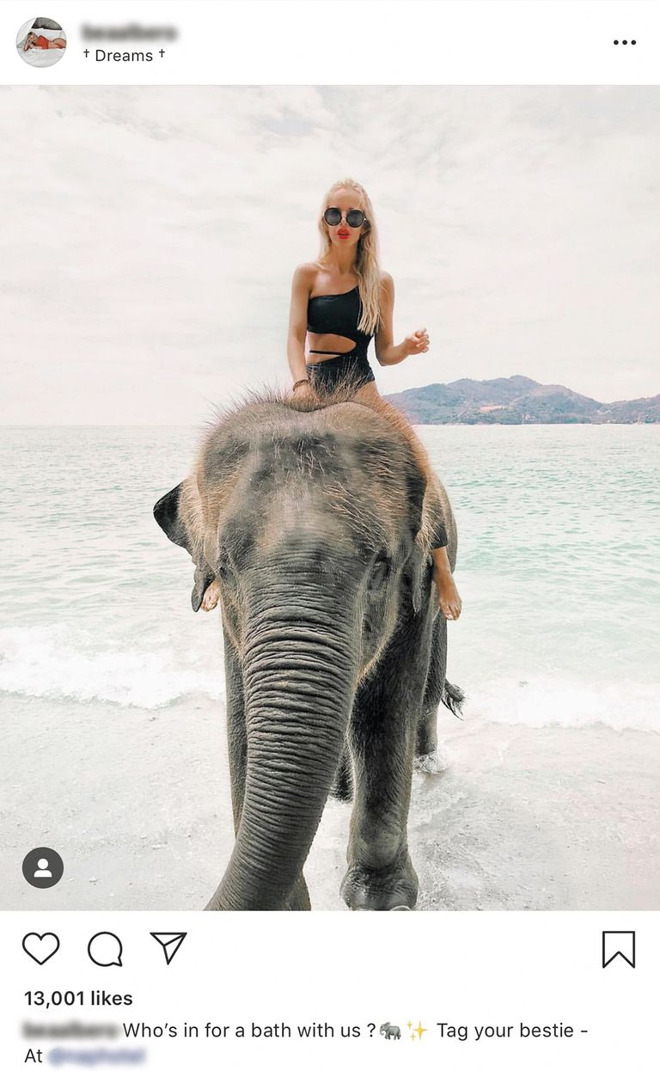

Measuring success: goals and objectives
________________________________________________________________________________________________

The measure of CAT’s success will be the establishment of dynamic goals and objectives that reflect the mission, as well as the four primary areas of emphasis (Literacy & Knowledge Translation, Conservation, Animal Welfare and Ethics, and Ecotourism). CAT will continue the work conducted by the Director for over 25 years on many different models and in several different contexts. Examples include work at the Chengdu Research Base of Giant Panda Breeding in China (Fennell & Guo, 2023) sled dogs (Fennell, 2022), bullfighting in Spain (Fennell & Sheppard, 2024), as well as Asian elephants (Shepherd & Fennell, 2020).

Goal 1 – Intensify research on animal-based tourism, especially on welfare and ethics

To undertake the most innovative and progressive research agenda to date in creating new knowledge designed to transform the academic landscape on animal-based tourism.

Objective 1
Attract and train top graduate students and postdoctoral scholars from around the world to work on targeted projects of the center.

Objective 2
Provide internship opportunities for undergraduate students who have shown an interest in
graduate work in the area of animals, tourism, welfare, and conservation.

Objective 3
Host international scholars and fund research on animal-based tourism in other regions of the
world.

Objective 4
Develop a library of resources on animal-based tourism, that will be available online to
scholars, practitioners, and policymakers.

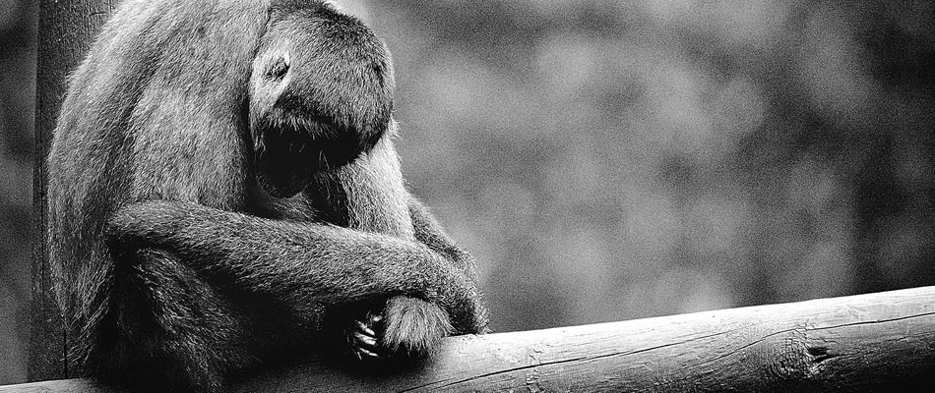

Goal 2 – Literacy & knowledge translation

To develop state-of-the-art educational policies and programs, at all levels, to transform tourism into a more sustainable and responsible industry when it comes to the treatment of animals.

Objective 1
Educate key industry stakeholders and sectors on the use of animals in tourism through the
Tourism Knowledge Translation framework (Fennell, 2021) for the purpose of putting new knowledge into the hands of industry practitioners as quickly as possible.

Objective 2
Provide knowledge and leadership for national and regional policymakers in changing the
future of tourism planning, development, and management.

Objective 3
Develop a third-party verification report card system to reward best practices in the animal-
based tourism industry.

Objective 4
Develop annual workshops, which allow industry and policy stakeholders to share challenges
and successes in the use of animals in tourism.

Objective 5
Undertake regional and global surveys of animal welfare literacy amongst tourists (Fennell,
2022a).

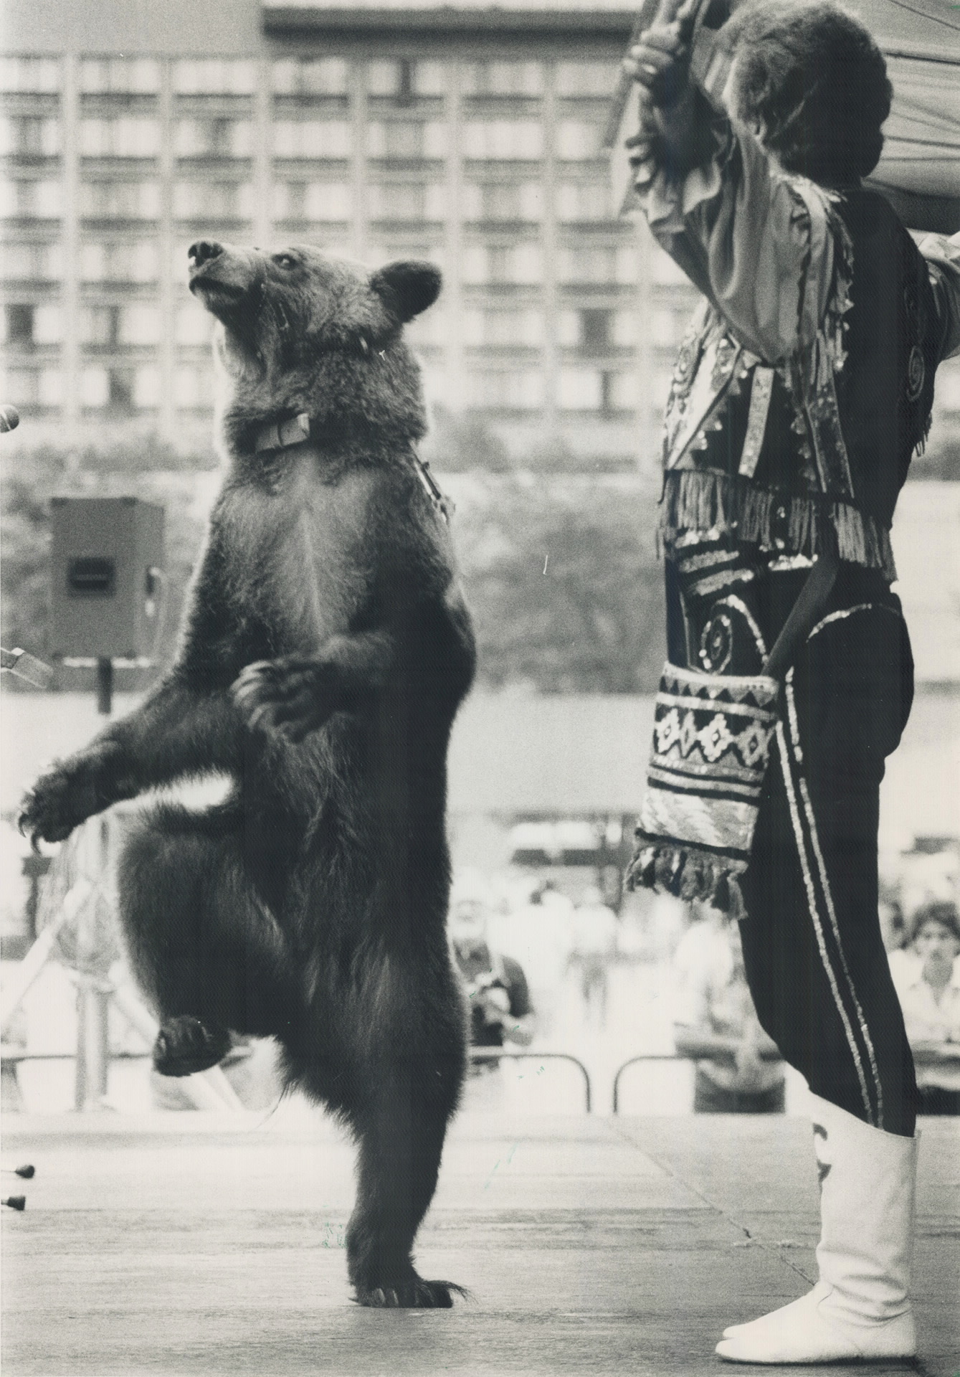
Goal 3 – Conservation

Biodiversity conservation concerns have traditionally focused on habitat loss, invasive species, pollution, human population growth, and overharvesting, and more recently climate change. New research, however, indicates that nature-based tourism should also be included on the list of human-induced rapid environmental change (HIREC) agents alongside these more historically recognized forms (Geffroy et al., 2015). Several studies cite biodiversity conservation challenges as a result of tourism, including prey vulnerability (Geffroy et al, 2015), habituation (Higham & Shelton, 2011), as well as from roads, vegetation trampling, and erosion of trials (Wolf et al., 2019).

Objective 1
To work directly with captive venues such as sanctuaries, who are designing tourism programs
to support the rehabilitation and reintroduction of animals that have been injured (e.g.,
electrocution, traffic accidents).

Objective 2:
To investigate how tourism is changing animal behavior as a result of tourism in parks. A
newly planned study with Dr. Jorge Rojas (a veterinarian) at Rancho Margot and the Tenorio-
Miravalles Biological Corridor is a case in point, where Baird's tapirs are habituating to people,
with humans creating strong bonds with these animals.

Objective 3:
To better understand conservation education in tourism, including the implementation of
citizen science and community stewardship programs to enhance community conservation.

Objective 4:
To investigate how tourism’s commodification of nature governs how we understand
conservation, i.e., conservation is evolving as a result of tourism organizations such as
Disney.

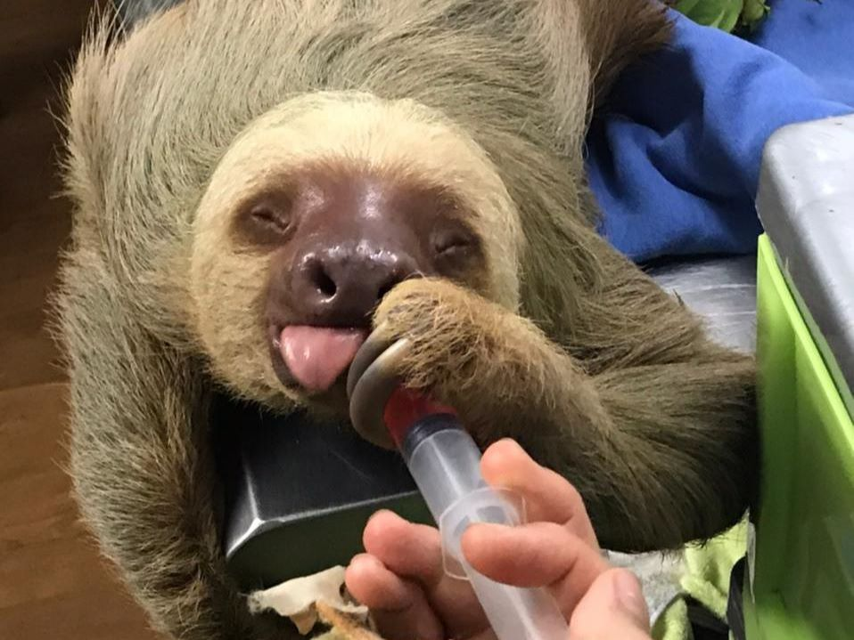

Goal 4 – Ecotourism

To work with local people (those working both directly and indirectly in tourism) in moving away from practices that cause animal suffering towards newer, more responsible uses of animals based around principles of ecotourism. Ecotourism can help. It is a form of tourism that focuses heavily on sustainability, learning about the environment, and ethical planning, development, and management. It’s a win-win situation for all if we can strike the right balance between decent work, reduction of poverty, good health and education, gender equality, and responsible consumption, while at the same time protecting the natural world and the interests of animals.

Objective 1
The use of ecotourism as a development strategy that has benefits over other economies such
as mining, logging, hunting.

Objective 2
Develop strategies and programs that demonstrate how ecotourism can be an essential form
of regeneration and rewilding.

Objective 3
Advocate the benefits of stewardship and volunteering in the ecotourism sector for the
benefit of both captive and wild animals.

Objective 4
Help local people use technology, social media, and other promotional devices to attract
tourists, and to share their best practice successes globally.

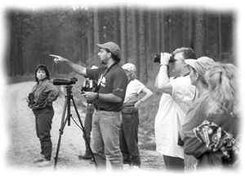

Proposed research projects
________________________________________________________________________________________________

Several innovative research projects are planned to tackle the complexities around the many negative practices that continue to plague the tourism industry’s use of animals. To be effective, our research will need to address several aspects of the industry, including politics and governance, economics and alternative livelihood strategies for local people, protected areas, socio-cultural practices, and animal-based tourism venues.

MA and PhD students, as well as postdoctoral scholars, will play an important role in changing the landscape of tourism and animal studies research in the future. Using the example of elephant tourism in Asia, the following projects will be undertaken:

- Elephant education, promotion, and information diffusion program to address how best to educate the tourism industry on why elephant tourism is wrong (e.g., riding elephants). Includes a focus on the use of social media.

- Develop an app to allow tourists to evaluate/rate animal-based venues according to conservation, welfare, and governance criteria. Such would allow for the development of
regional and global standards to enable tourists to better understand ethical and unethical
treatment of animals like elephants.

- Willingness to pay, and the personal costs and benefits of participating in elephant tourism from the perspective of practitioners and tourists. Negative uses of elephants will bear social costs as the industry becomes better educated on impacts to animals.

- The creation of animal welfare and cruelty surveys to measure gender and cross-cultural differences of people who participate in elephant tourism.

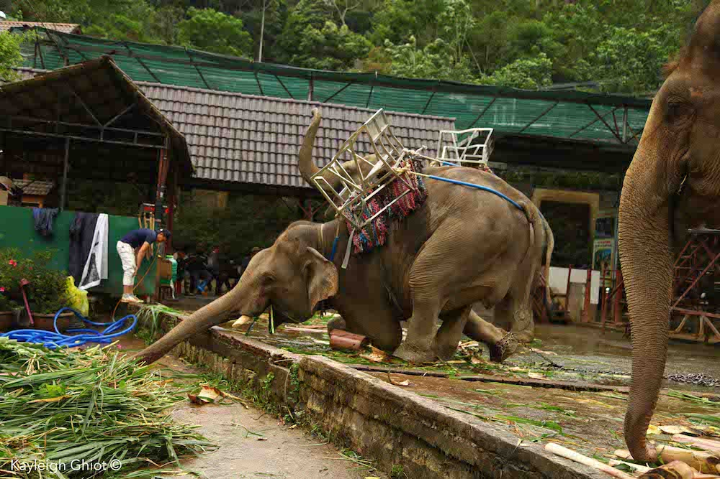

- Justice for elephants. What does injustice look like in environments where moral and cultural practices reinforce cruelty and neglect (Fennell & Sheppard, 2020)?

- Developing and testing models of ecotourism development, which work in different situations and settings in moving away from cruel animal practices. This topic would build upon United Nations Sustainable Development Goal 8 on Decent Work and Economic Growth.

- The institutional arrangements that allow for elephant tourism to exist, in addition to how these practices ought to change based on theories of environmental governance, conservation, welfare, and community development.

- Determine how existing protected areas work towards sustaining elephant populations, as well as how sanctuaries may be more suitable because of poaching and institutional failure within public protected areas.

- Animal-informed consent, or how animals assent (or dissent) to their use as tourism attractions or workers (Fennell, 2022b).

- The use of integrative social contracts theory to reconcile how global principles can work with local practices for sound animal conservation and welfare, and successful ecotourism development (Fennell, 2022c).

- The use of nonviolent communication as a vehicle to improve relations between animals and local people in elevating the conservation and welfare status of animals used in tourism.

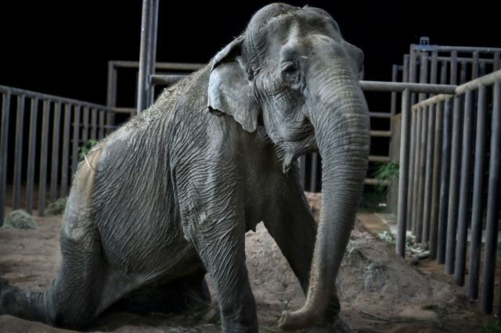

Realizing the vision
________________________________________________________________________________________________

Corporate strategists recognize that the biggest global players have the biggest global responsibility. For example, Lawler (2015) writes in Forbes magazine that corporations are now taking the lead as global stewards—as an ethical imperative—regarding many of the challenges facing the planet. There is acknowledgment that a healthy biosphere is a precondition for economic success, sustainability, and social justice at all scales of development (Folke et al., 2016). Furthermore, there is recognition that “giving” corporations realize higher profitability, productivity, efficiency, and customer satisfaction; and these firms build cohesive and strong cultures that have appeal to customers, supplies, and top talent (Podsakoff et al., 2009).

CAT is looking for a founding sponsor. This champion will have full naming rights and will provide the long-term leadership and resources needed to realize our vision. The sponsor will share the same values and priorities as CAT and will help build a productive and innovative partnership that strives for global change.

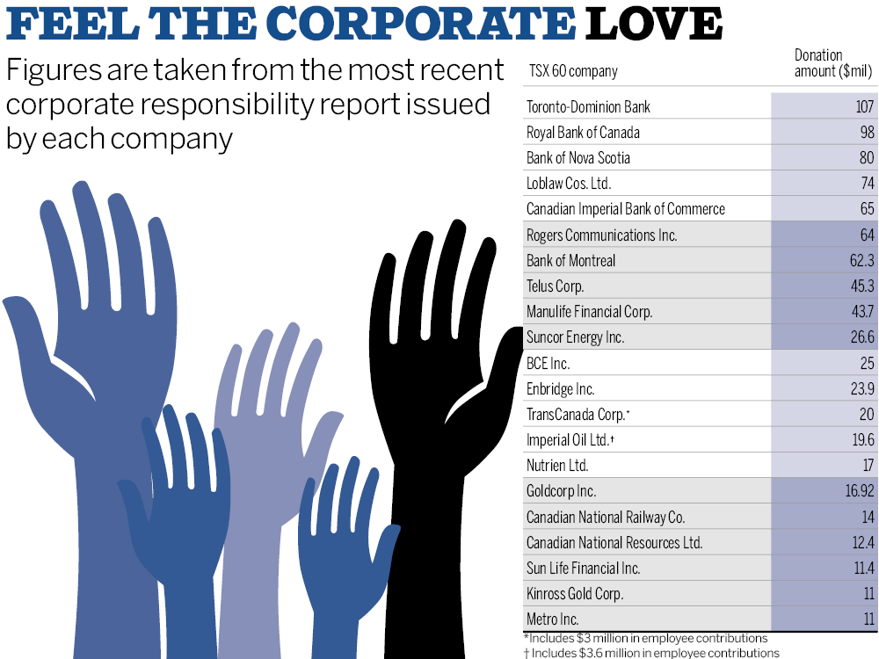

Budget
______________________________________________________________________

The following represent most of the expected expenditures for the ongoing and sustained operation of the Centre for Animal-based Tourism

Centre Personnel
- Directors: No salary or benefits
- Part-time administrative assistant
- Part-time research assistant: grant writing, marketing, social media
- Knowledge translation specialists (2)
Research
- Scholar collaborative grants with CAT
- Graduate student research assistants
- Host a post-doctoral scholar
- Host a visiting scholar (1 week)
- Open access for publishing
- Qualtrics for survey research
- Meetings for Directors
- Conference attendance
Operational
- Computer equipment, camera gear, etc.
- Logo, website, stationary, copying, etc.
- Commercial space
- Miscellaneous
- Donation to global best practice sanctuaries

References
_______________________________________________________________________________________

Curtin, S. & Wilkes, J. (2008). Swimming with captive dolphins: current debates and post-experience dissonance. International Journal of Tourism Research, 9(2), 131-146.

Eilperin, J. (2012). Study shows lion population plummeting as habitat disappears. Retrieved at https://www.independent.co.uk/news/world/africa/study-shows-lion-population-plummeting-as-habitat-disappears-8385715.html

Fennell, D.A. (In press). Animal health warning labels in wildlife tourism. Journal of Ecotourism,

Fennell, D. A. (2022a). Progressing towards animal welfare literacy in tourism. Annals of Tourism Research, 96, https://doi.org/10.1016/j.annals.2022.103461

Fennell, D. A. (2022). Animal-Informed Consent: Sled dog tours as asymmetric agential events. Tourism Management, 93, https://doi.org/10.1016/j.tourman.2022.104584.

Fennell, D. A. (2022c). Bridging the global-local wildlife tourism divide. Annals of Tourism Research, 96, https://doi.org/10.1016/j.annals.2022.103459.

Fennell, D. A. (2021). The tourism knowledge translation framework: Bridging theory and practice. Current Issues in Tourism, DOI: 10.1080/13683500.2021.1887099.

Fennell, D. A. (2020) (5th Ed.). Ecotourism. London: Routledge.

Fennell, D. A. (2018) (2nd Ed.). Tourism ethics. Clevedon: Channel View Publications.

Fennell, D.A. (2012). Tourism and animal ethics. London: Routledge.

Fennell, D. A. & Cooper, C. (2020). Sustainable tourism. Bristol, UK: Channel View Publications.

Fennell, D.A., Guo, Y. (2023). Ubiquitous love or not? Animal welfare and animal-informed consent in giant panda tourism. Animals, 13, 718. https:// doi.org/10.3390/ani13040718.

Fennell, D. A. A & Sheppard, V. (2024). Bullfighting as dark tourism: Cultural experience or anachronism? Frontiers in Sustainable Tourism, 3, doi:10.3389/frust.2024.1309000.

Fennell, D. A. & Sheppard, V. (2020). Tourism, animals and the scales of justice. Journal of Sustainable Tourism, DOI: 10.1080/09669582.2020.1768263

Folke, C., R. Biggs, A. V. Norström, B. Reyers, and J. Rockström. 2016. Social-ecological resilience and biosphere-based sustainability science. Ecology and Society, 21(3):41. http://dx.doi.org/10.5751/ES-08748-210341

Geffroy, B., Samia, S., Bessa, E., & Blumstein, D. (2015). How nature-based tourism might increase prey vulnerability to predators. Trends in Ecology & Evolution, 30(12), 755–765.

Graham, L. (2010). Elephant Phajaan. Retrieved December 4, 2013, from http://www.critters360.
com/index.php/elephant-phajaan-9120/

Hamilton, C. (2017). Defiant earth: the fate of humans in the Anthropocene. Cambridge, UK: Polity.

Higham, J. E. S., Bejder, L., Allen, S. J., Corkeron, P. J., & Lusseau, D. (2016). Managing whale-watching as a non-lethal consumptive activity. Journal of Sustainable Tourism, 24, 73-90.

Lawler III, E. E. (2015). Corporate stewardship. Retrieved at https://www.forbes.com/sites/edwardlawler/2015/09/22/corporate-stewardship/#40b5ace1b257

Lewis, S. L. & Masin, M. A. (2015) Defining the anthropocene. Nature 519, 171-180.
Orangutan Conservancy (2019). Threats to orangutans. Retrieved at https://www.orangutan.com/threats-to-orangutans/

Phillips, C. (2009). The scale and intensity of the world's animal industries. In Phillips, C. (Ed.) The welfare of animals: the silent majority (pp. 149-172). Amsterdam. Springer.

Podsakoff, N. P., Whiting, S. W., Podsakoff, P. M., & Blume, B. D. (2009). Individual- and organizational-level consequences of organizational citizenship behaviors: A meta-analysis. Journal of Applied Psychology, 94 (1), 122-141.

Steyn, P. (2016). African elephant numbers plummet 30 percent, landmark survey finds. Retrieved at https://www.nationalgeographic.com/news/2016/08/wildlife-african-elephants-population-decrease-great-elephant-census/#close

Wolf, I. D., Croft, D. B., & Green, R. J. (2019). Nature conservation and nature-based tourism: A paradox. Environments, 6, 104; doi:\10.3390/environments6090104.

World Wildlife Fund (2019). Mountain gorilla. Retrieved at https://wwf.panda.org/knowledge_hub/endangered_species/great_apes/gorillas/mountain_gorilla/

